Contents

Problem geometry 4

Enclosure: 4

Body of influence 4

Problem meshing 5

Problem setup 6

General 6

Model 6

Body force formulation 6

Surface tension 6

Surface tension force modelling 6

Turbulence model 6

Boundary conditions 6

Solution method 7

Solution controls: 7

Initialization: 7

Calculation 7

Results 7

The results were taken after 1.6 seconds 7

Validation 10

Validation with the paper (al Y. e., 2022) 10

Validation with the experiment (al, Experimental investigation of supercavitating flows, 2012) 10

Mesh convergence analysis 11

Simulation Data 11

Calculation of Pressure Differences 11

Results and Discussion 11

Mesh Convergence: Pressure Values 11

Mesh Convergence: Pressure Difference 12

Conclusion 13

Problem geometry 14

Enclosure: 14

Body of influence 14

Problem meshing 15

Problem setup 16

General 16

Model 16

Homogeneous Models 16

volume fraction parameters formulation 16

Body force formulation 16

Turbulence model 16

Boundary conditions 16

Solution method 17

Solution controls: 17

Initialization: 17

Calculation 17

Results 17

The results were taken after 1.6 seconds 17

Problem geometry 20

Enclosure: 20

Body of influence 20

Problem meshing (using Fluent mesher) 21

Problem setup 22

General 22

Model 22

Homogeneous Models 22

volume fraction parameters formulation 22

Body force formulation 22

Turbulence model 22

Boundary conditions 22

Solution method 23

Solution controls: 23

Initialization: 23

Calculation 23

Results 23

The results were taken after 1.6 seconds 23

Comparison between Cavitator Design 40 deg and 60 deg 26

40deg 26

60deg 26

References 27

CFD simulation of ventilated cavitation

# Problem geometry

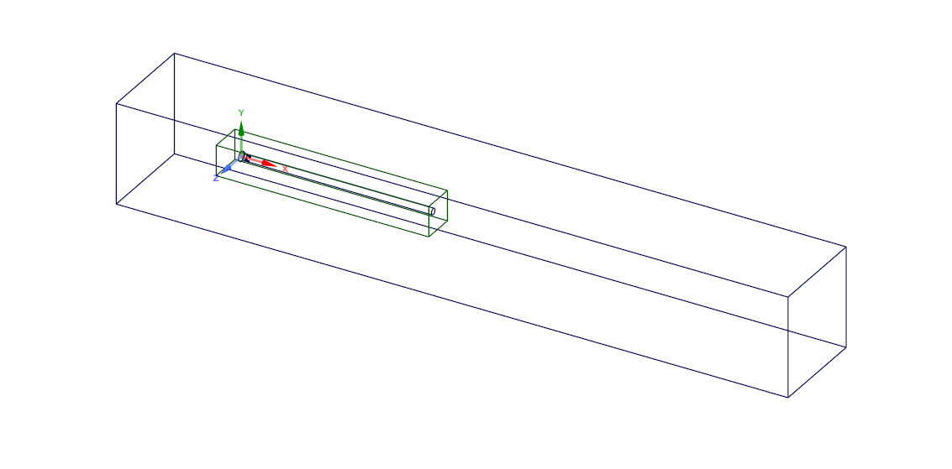

Figure 1

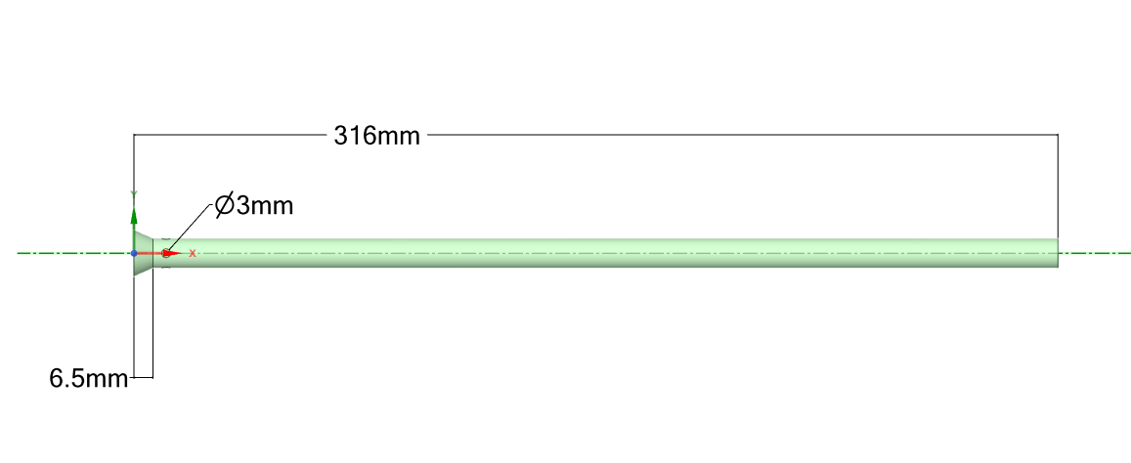

Figure 2

### Enclosure:

|  |  |
| --- | --- |
| X- | 158mm |
| X+ | 632mm |
| Y- | 75mm |
| Y+ | 75mm |
| Z- | 75mm |
| Z+ | 75mm |

### Body of influence

53.3*50*350 mm

# Problem meshing

Number of elements: 1683729

Body of influence is used to refine cell size around the cylinder with element size = 2mm.

30 inflation layers are added above cylinders walls with growth rate 1.05 and transition ratio 0.272.

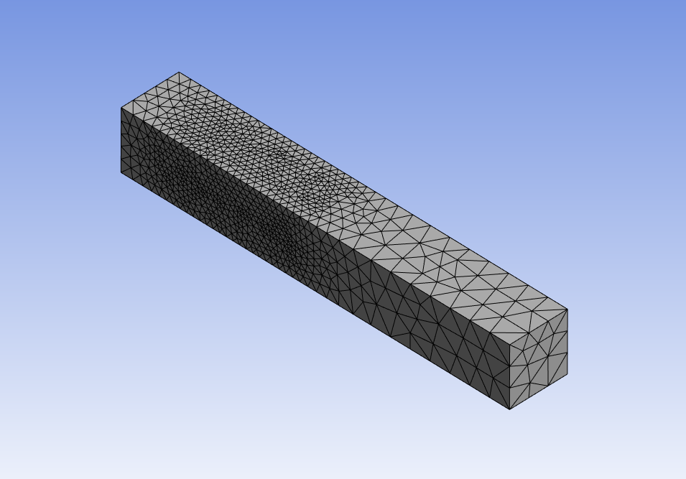

Figure 3

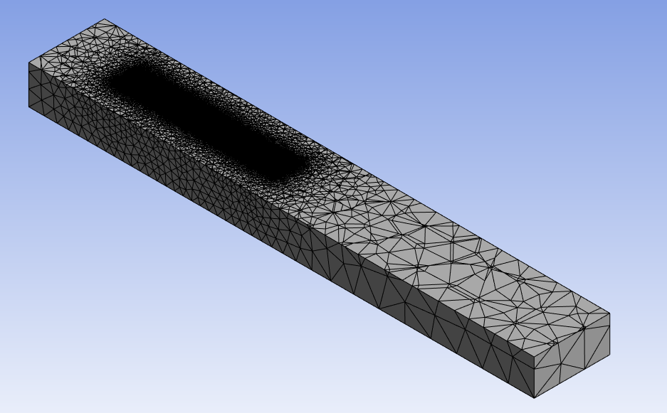

Figure 4

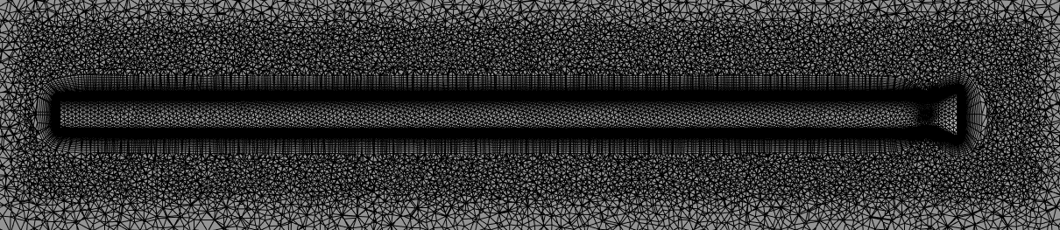

Figure 5

# Problem setup

## General

Gravity=-9.81 m/s2

Energy: off

## Model

Multiphase VOF model with no mass transfer between the two phases

Primary phase: Water, Secondary phase: Air

Body force formulation

implicit body force

### Surface tension

constant coefficient = 0.072 N/m

### Surface tension force modelling

Model: continuum surface force

Adhesions options: wall adhesion

## Turbulence model

k-omega SST

## Boundary conditions

Equation:

Where,

|  |  |  |  |
| --- | --- | --- | --- |
| Inlet name | Type | Value | Air phase fraction |
| Main inlet | velocity | 6m/s | 0 |
| Inlet slot 1 | Mass flow | Expression | 1 |
| Inlet slot 1 | Mass flow | Expression | 1 |
| Inlet slot 1 | Mass flow | Expression | 1 |
| Inlet slot 1 | Mass flow | Expression | 1 |
| Outlet | Pressure outlet | 82 Kpa-gauge pressure | Backflow air VF 1 |
| Far-field | Velocity inlet in x | wall | 0 |

Expression

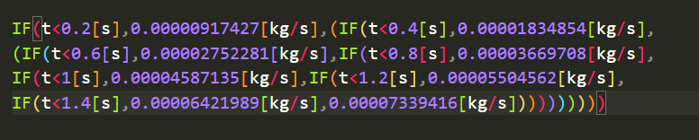

## Solution method

Couped algorithm with all spatial discretization settings as default.

### Solution controls:

All under-relaxation factors are left as default.

## Initialization:

Hybrid initialization.

## Calculation

Number of time step :16000, time step size :0.0001, Max iterations=20

# Results

## The results were taken after 1.6 seconds

Froude number = 15.24011356

Cavitation number =

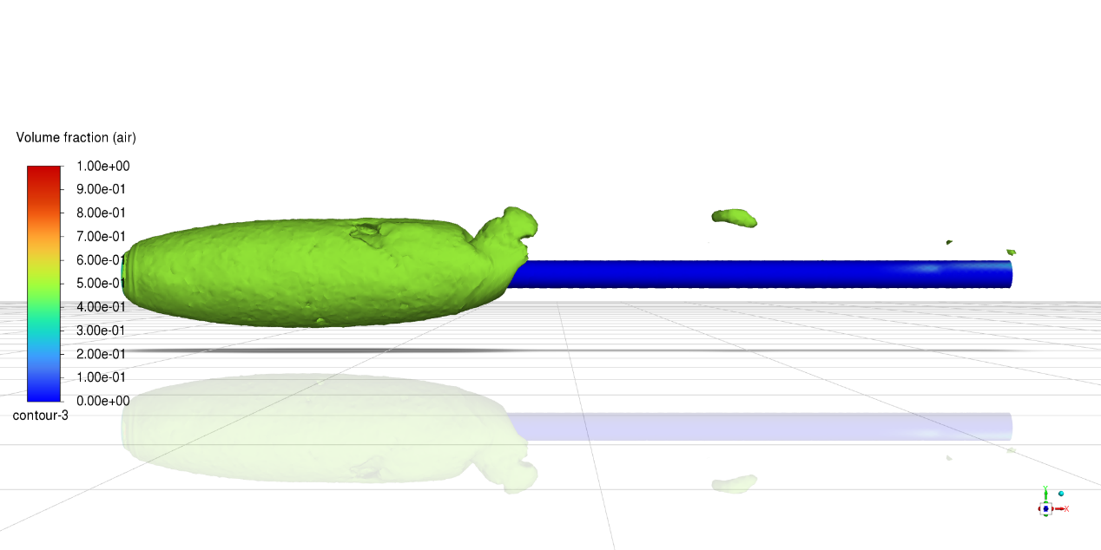

Figure 6 : Air VF iso surface 0.5

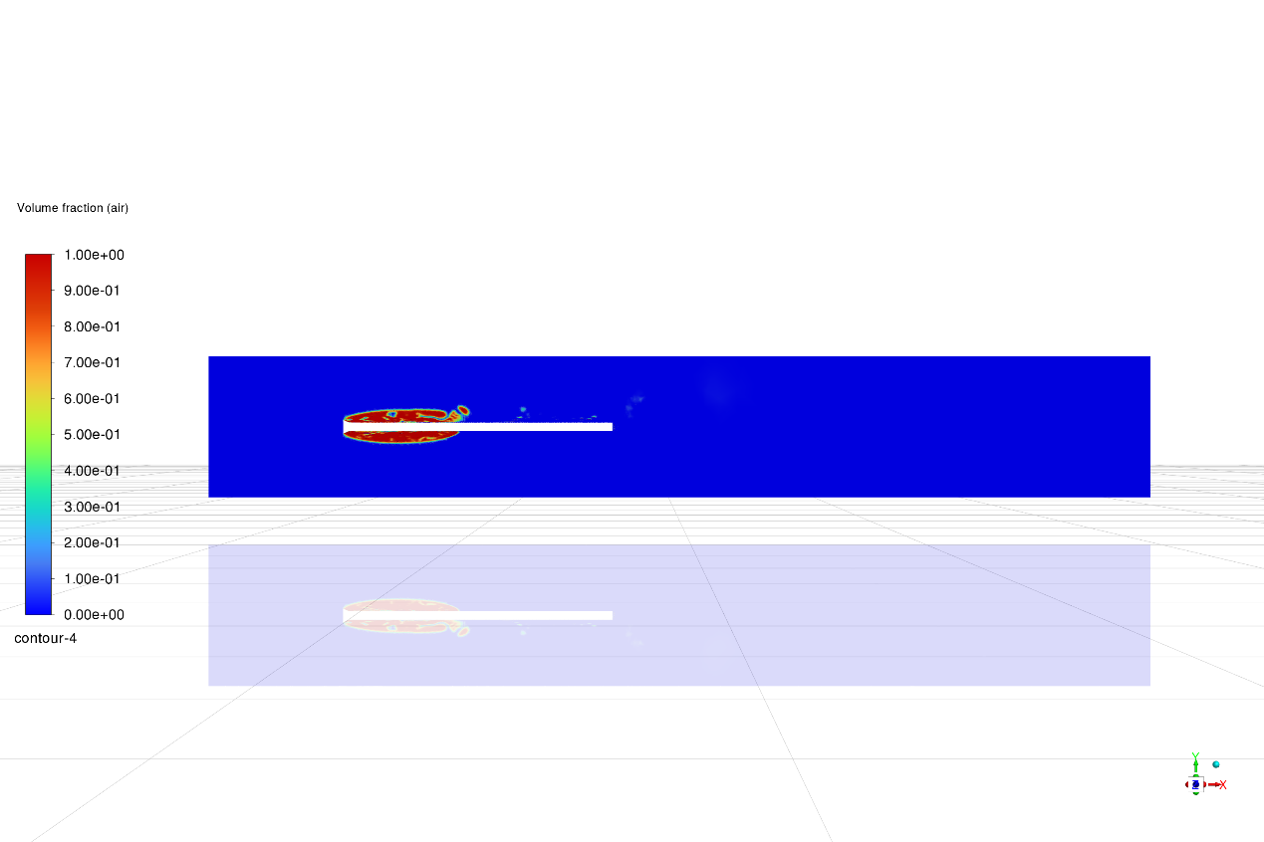

Figure 7 Air VF

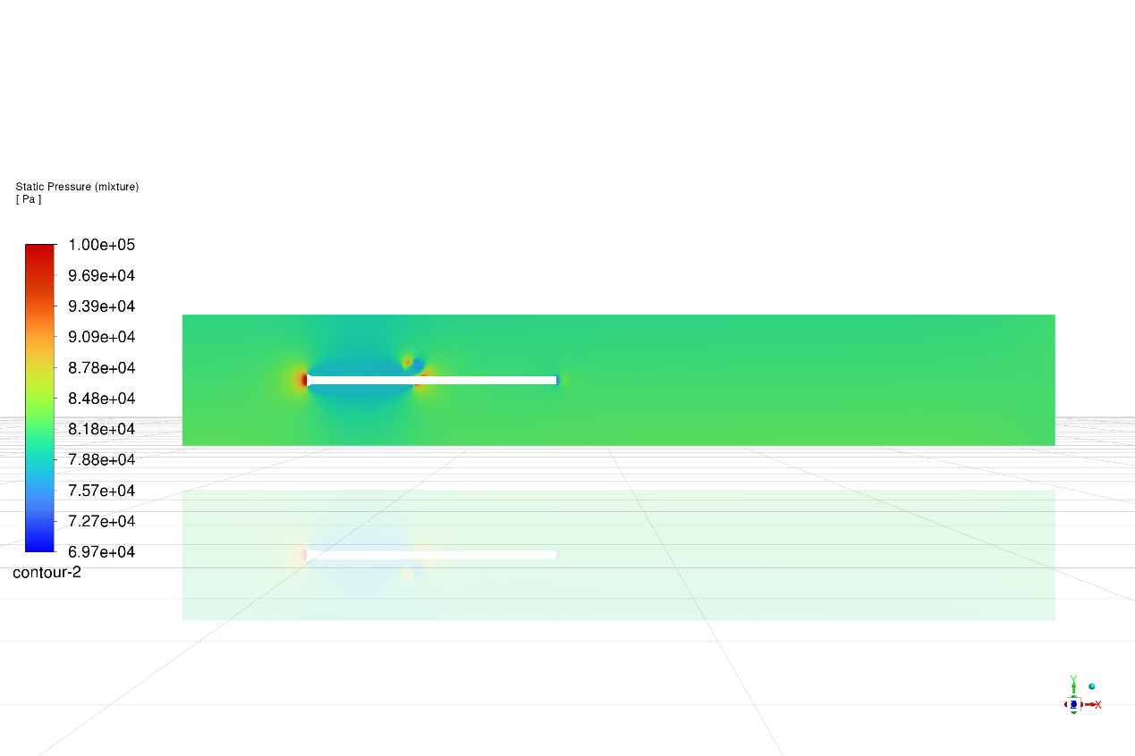

Figure 8 Pressure distribution

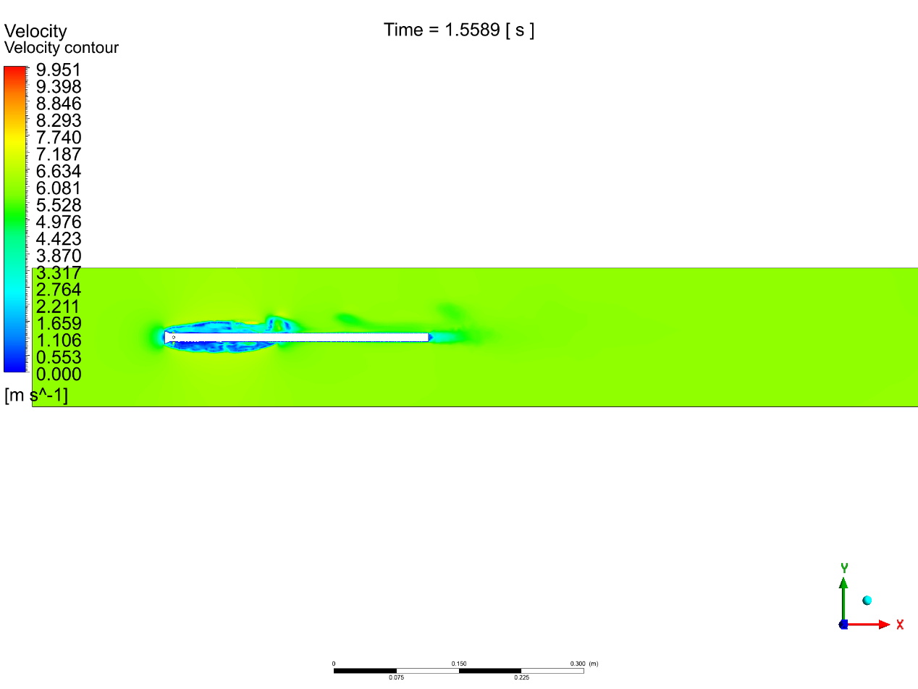

Figure 9 Velocity contour

## Validation

### Validation with the paper (al Y. e., 2022)

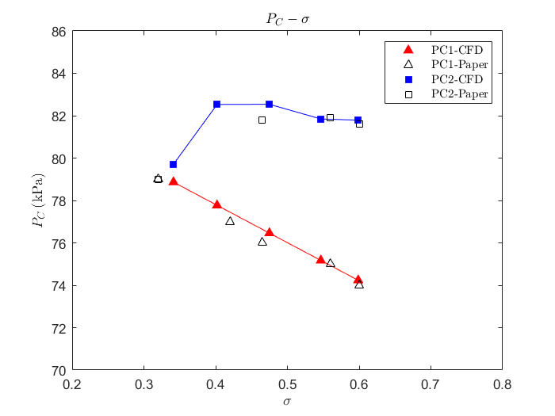

### Validation with the experiment (al A. e., Experimental investigation of supercavitating flows, 2012)

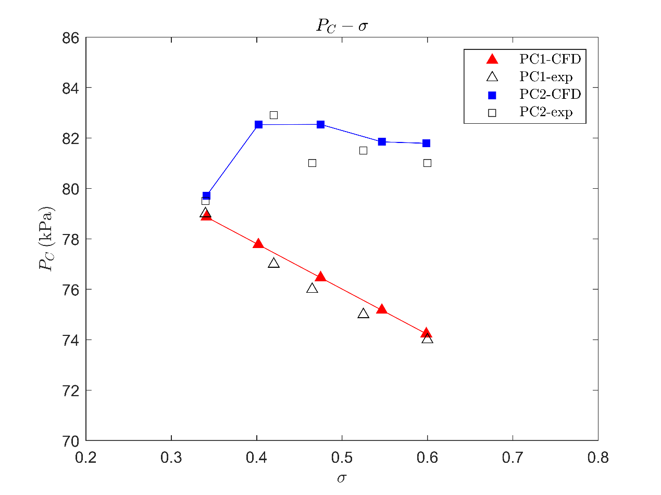

# Mesh convergence analysis

The simulations were performed using different mesh sizes to observe the effect on the calculated cavity pressure. The mesh sizes used are:

* Mesh 1: 1,129,520 elements
* Mesh 2: 1,406,609 elements
* Mesh 3: 1,683,729 elements
* Mesh 4: 2,093,996 elements

### Simulation Data

The following cavitation numbers and cavity pressures were calculated for different mesh sizes at :

* **Mesh 1**: Cavitation Number = 0.439680, Pressure = 77.1095 kPa
* **Mesh 2**: Cavitation Number =0.400356, Pressure = 77.8152 kPa
* **Mesh 3**: Cavitation Number = 0.391753, Pressure = 77.9696 kPa
* **Mesh4**: Cavitation Number =0.388722, Pressure = 78.024kPa

### Calculation of Pressure Differences

Pressure differences were calculated to compare the simulation results with experimental and paper data:

## Results and Discussion

### Mesh Convergence: Pressure Values

The first plot shows the actual cavity pressure values for different mesh sizes:



Plot Description

* This plot helps to ensure that the pressure values stabilize and do not change significantly with finer meshes.

### Mesh Convergence: Pressure Difference

The second plot shows the pressure difference as a function of the number of mesh elements:



* Pressure differences between the simulation and paper data.
* Pressure differences between the simulation and experimental data.
* All simulations were run performed at a

Plot Description

* This plot helps to determine the mesh size at which the pressure difference stabilizes, indicating mesh independence.
* A decrease in pressure difference with increasing mesh size suggests convergence.

## Conclusion

The mesh convergence analysis confirms that the CFD simulation results for super-ventilated cavitation in an underwater vehicle become mesh-independent as the mesh size increases. The pressure differences between the simulation and experimental data decrease with finer meshes, indicating convergence. The results demonstrate the importance of performing mesh convergence analysis to ensure accurate and reliable CFD simulations.

CFD simulation of Cavitator Design 40 deg angle

# Problem geometry

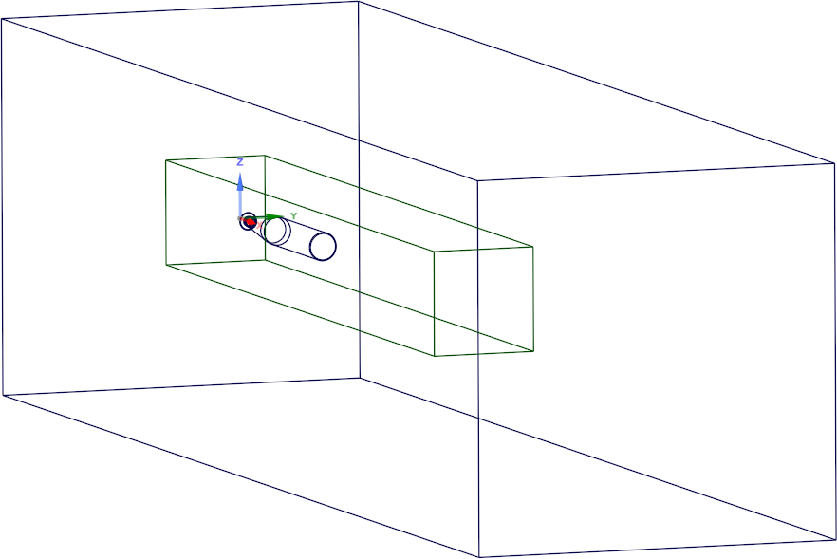

Figure 1

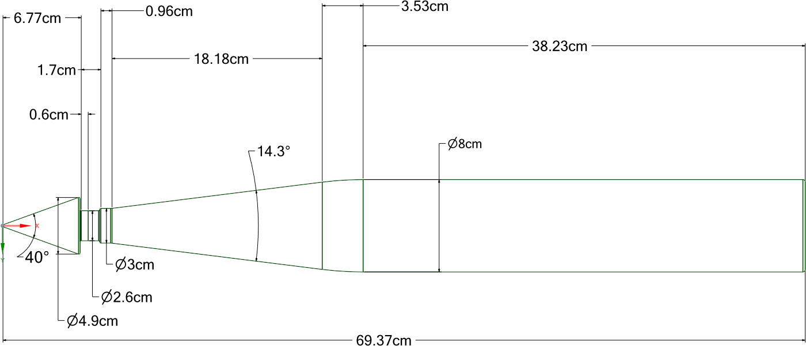

Figure 2

### Enclosure:

|  |  |
| --- | --- |
| X- | 50cm |
| X+ | 349.4cm |
| Y- | 54cm |
| Y+ | 54cm |
| Z- | 54cm |
| Z+ | 54cm |

### Body of influence

30*30*225 cm

# Problem meshing

Number of elements: 4161474

Body of influence is used to refine cell size around the cylinder with element size = 9.5mm.

30 inflation layers are added above cylinders walls with growth rate 1.21 and first-layer thickness is 0.0047 mm.

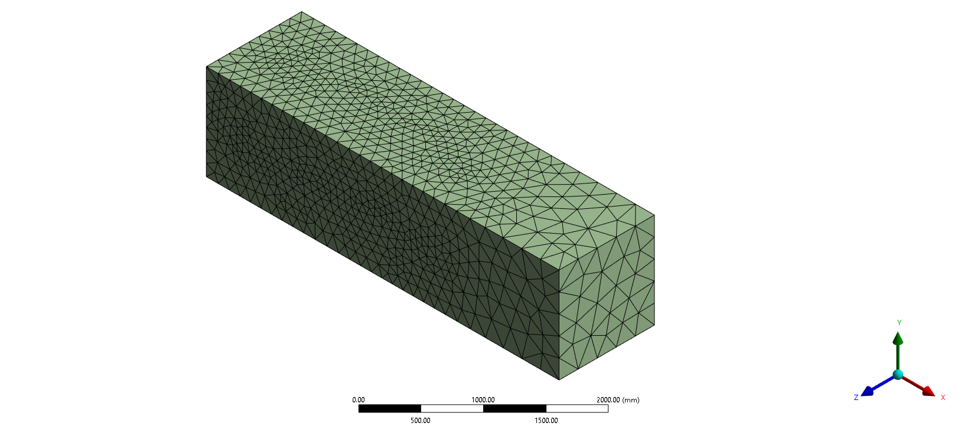

Figure 3

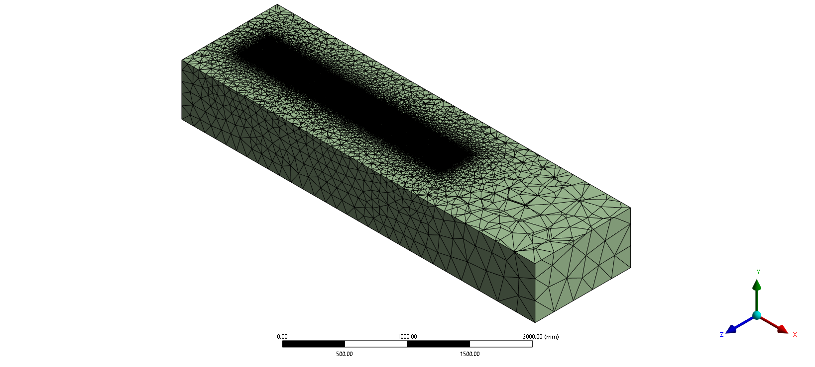

Figure 4

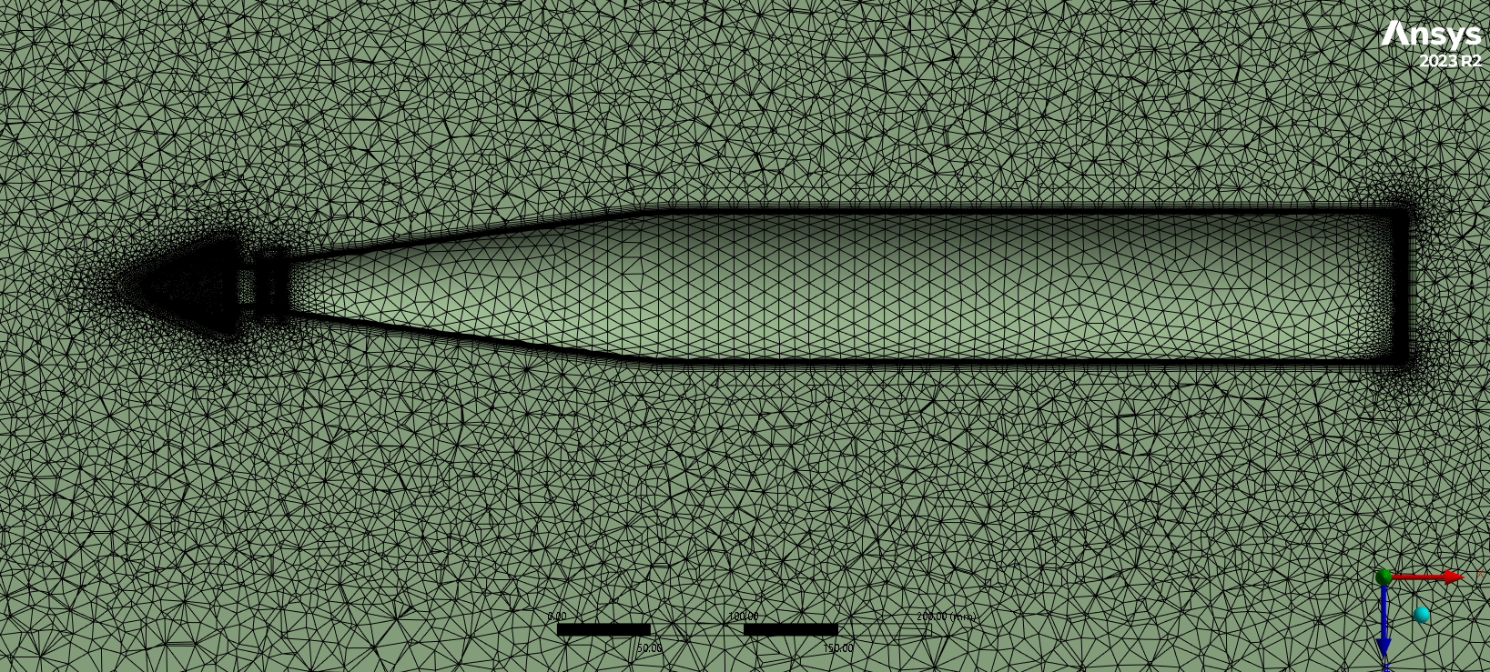

Figure 5

# Problem setup

## General

in y-direction

Energy: off

## Model

Multiphase VOF model with no mass transfer between the two phases

Primary phase: Water, Secondary phase: Air

Homogeneous Models

volume of fluid

volume fraction parameters formulation

implicit

Body force formulation

implicit body force

## Turbulence model

k-omega SST

## Boundary conditions

Equation:

Were,

|  |  |  |  |
| --- | --- | --- | --- |
| Inlet name | Type | Value | Air phase fraction |
| Main inlet | velocity | 9.17 m/s | 0 |
| Inlet vents | Mass flow | 30 m/s | 1 |
| Outlet | Pressure outlet | zero-gauge pressure | Backflow air VF 1 |
| cavitator-walls | wall |  | |
| Far-field | wall |

## Solution method

Couped algorithm with all spatial discretization settings as default.

### Solution controls:

All under-relaxation factors are left as default.

## Initialization:

Hybrid initialization.

## Calculation

Number of time step :3200, time step size: 0.0005, Max iterations=20

# Results

## The results were taken after 1.6 seconds

Froude number = 13.22625197

|  |  |  |
| --- | --- | --- |
| Cavitation number calculation | | |
|  |  |  |
|  |  |  |
|  |  |  |
|  |  |  |
|  |  |  |
| Sensor Location | | |
| x | y | z |
| 0.744 m | 0 | 0 |

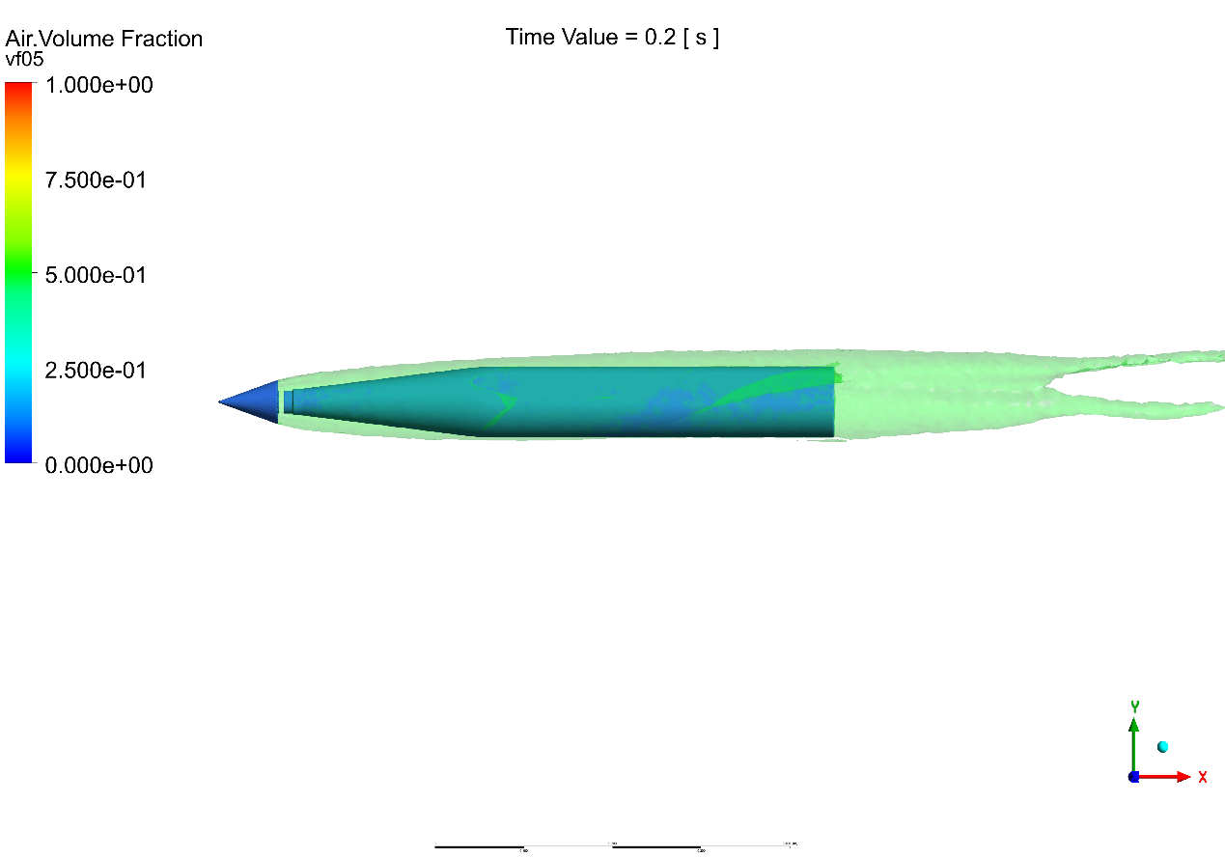

Figure 6 : Air VF iso surface 0.5

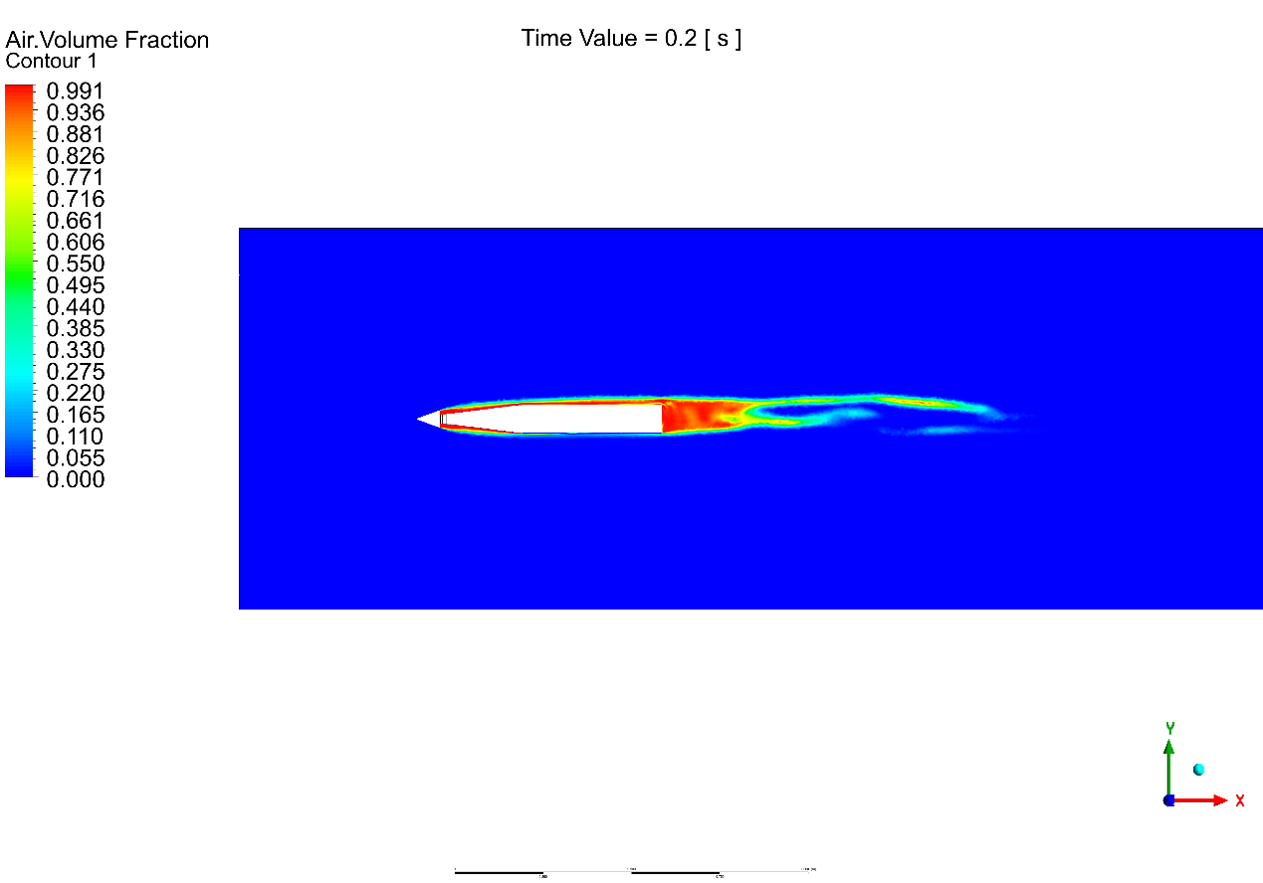

Figure 7 Air VF

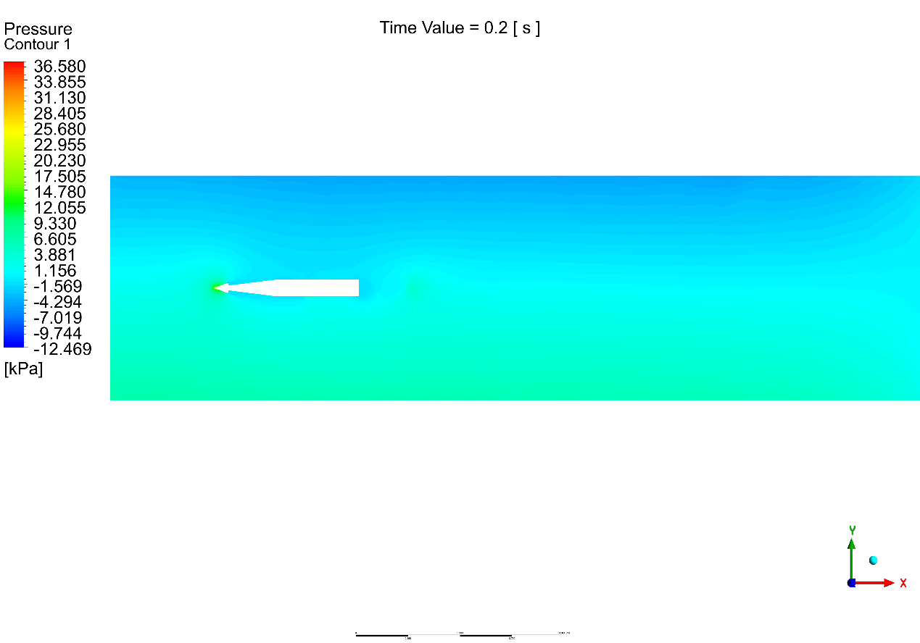

Figure 8 Pressure distribution

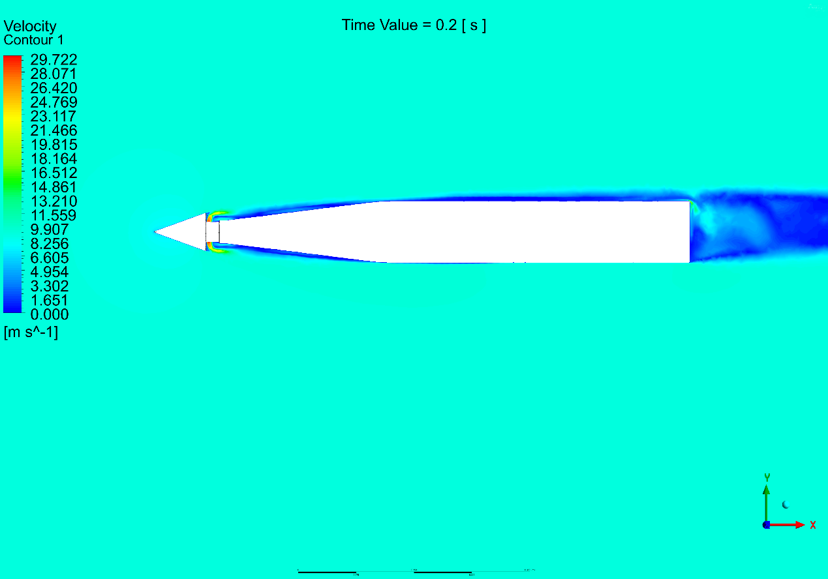

Figure 9 velocity distribution

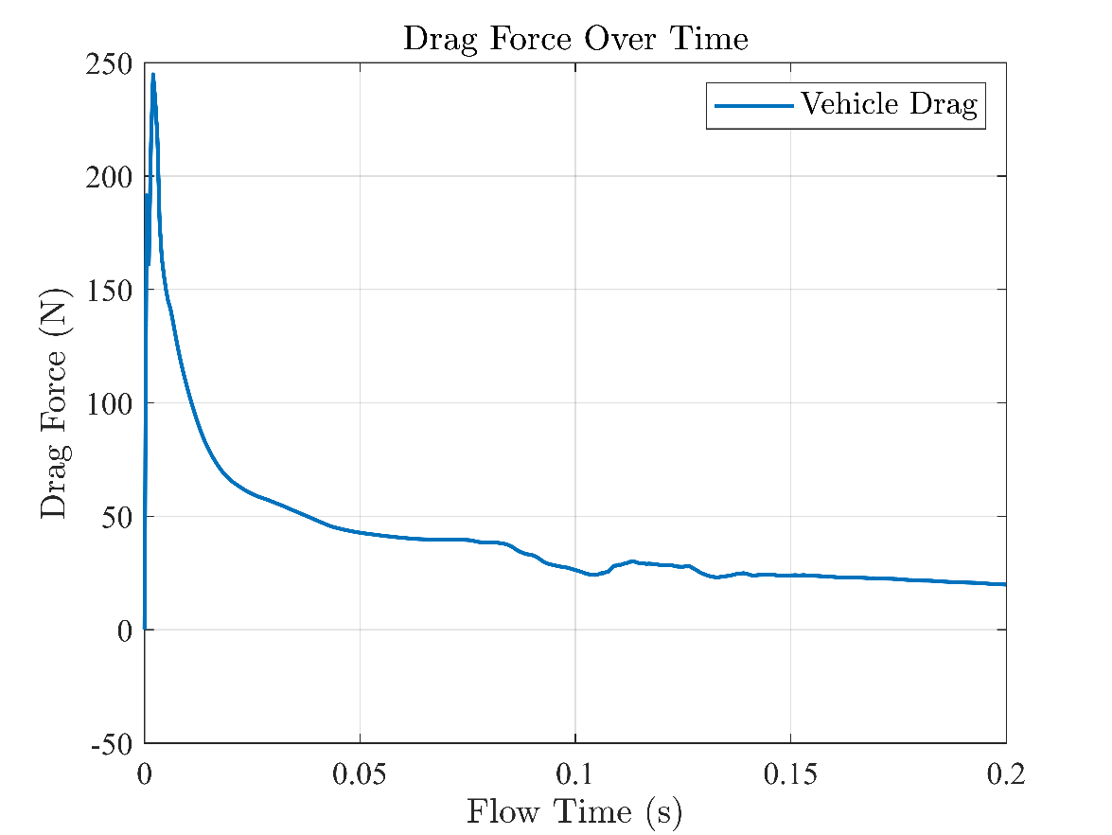

Figure 10 drag with time

CFD simulation of Cavitator Design 60 deg angle (Kim)

# Problem geometry

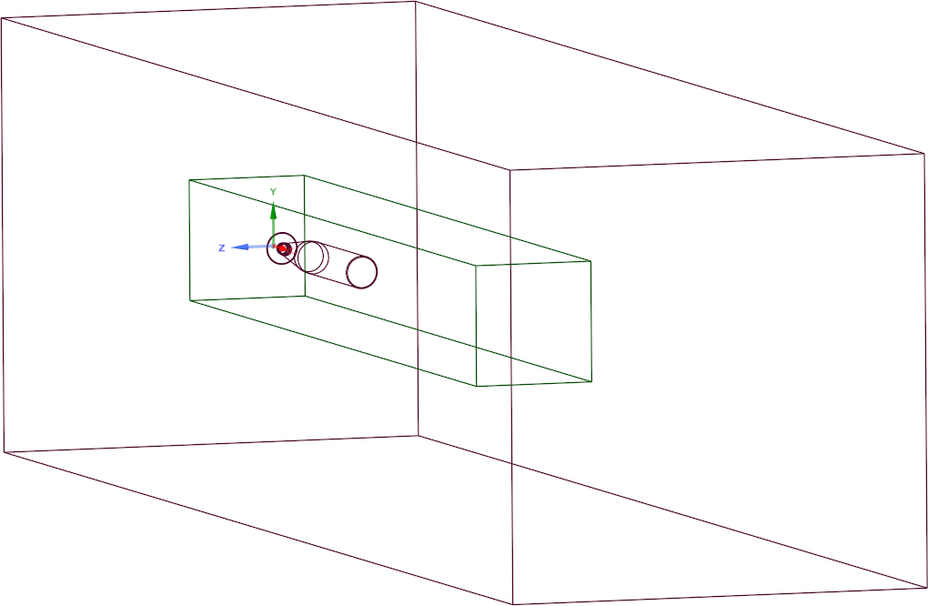

Figure 1

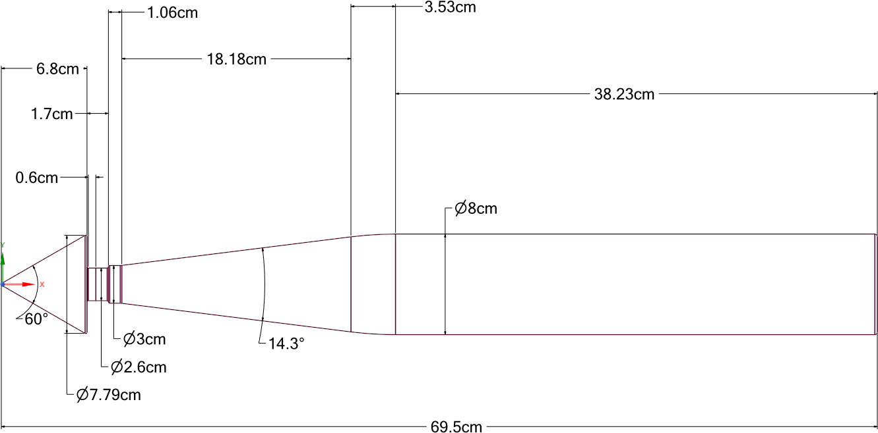

Figure 2

### Enclosure:

|  |  |
| --- | --- |
| X- | 50cm |
| X+ | 349.4cm |
| Y- | 54cm |
| Y+ | 54cm |
| Z- | 54cm |
| Z+ | 54cm |

### Body of influence

30*30*225 cm

# Problem meshing (using Fluent mesher)

Number of elements: 10184237

Body of influence is used to refine cell size around the cylinder with element size = 10mm.

30 inflation layers are added above cylinders walls with growth rate 1.21 and first-layer thickness is 0.0047 mm.

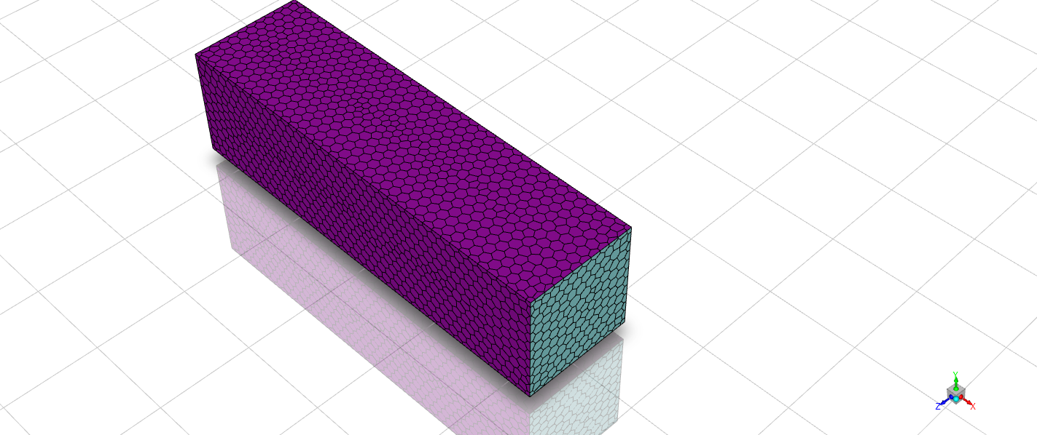

Figure 3

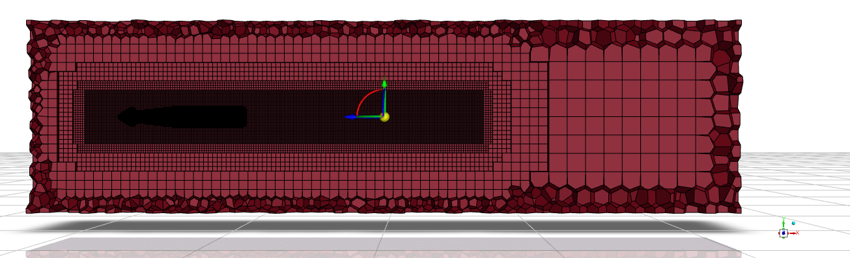

Figure 4

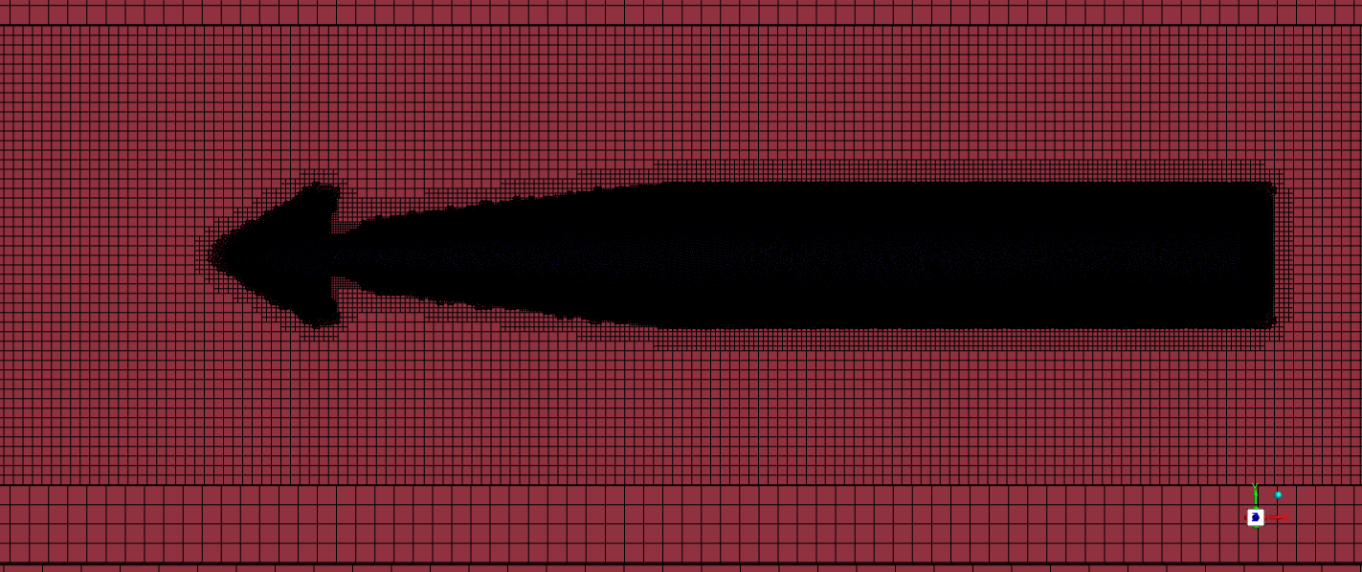

Figure 5

# Problem setup

## General

in y-direction

Energy: off

## Model

Multiphase VOF model with no mass transfer between the two phases

Primary phase: Water, Secondary phase: Air

Homogeneous Models

volume of fluid

volume fraction parameters formulation

implicit

Body force formulation

implicit body force

## Turbulence model

k-omega SST

## Boundary conditions

Equation:

Were,

|  |  |  |  |
| --- | --- | --- | --- |
| Inlet name | Type | Value | Air phase fraction |
| Main inlet | velocity | 9.17 m/s | 0 |
| Inlet vents | Mass flow | 30 m/s | 1 |
| Outlet | Pressure outlet | zero-gauge pressure | Backflow air VF 1 |
| cavitator-walls | wall |  | |
| Far-field | wall |

## Solution method

Couped algorithm with all spatial discretization settings as default.

### Solution controls:

All under-relaxation factors are left as default.

## Initialization:

Hybrid initialization.

## Calculation

Number of time step :3200, time step size: 0.0005, Max iterations=20

# Results

## The results were taken after 1.6 seconds

Froude number

|  |  |  |
| --- | --- | --- |
| Cavitation number calculation | | |
|  | 1.69 |  |
|  | -2.26854 |  |
|  | 9.17 |  |
|  | 999 |  |
|  | 0.094147485 |  |
| Sensor Location | | |
| x | y | z |
| 0.744 m | 0 | 0 |

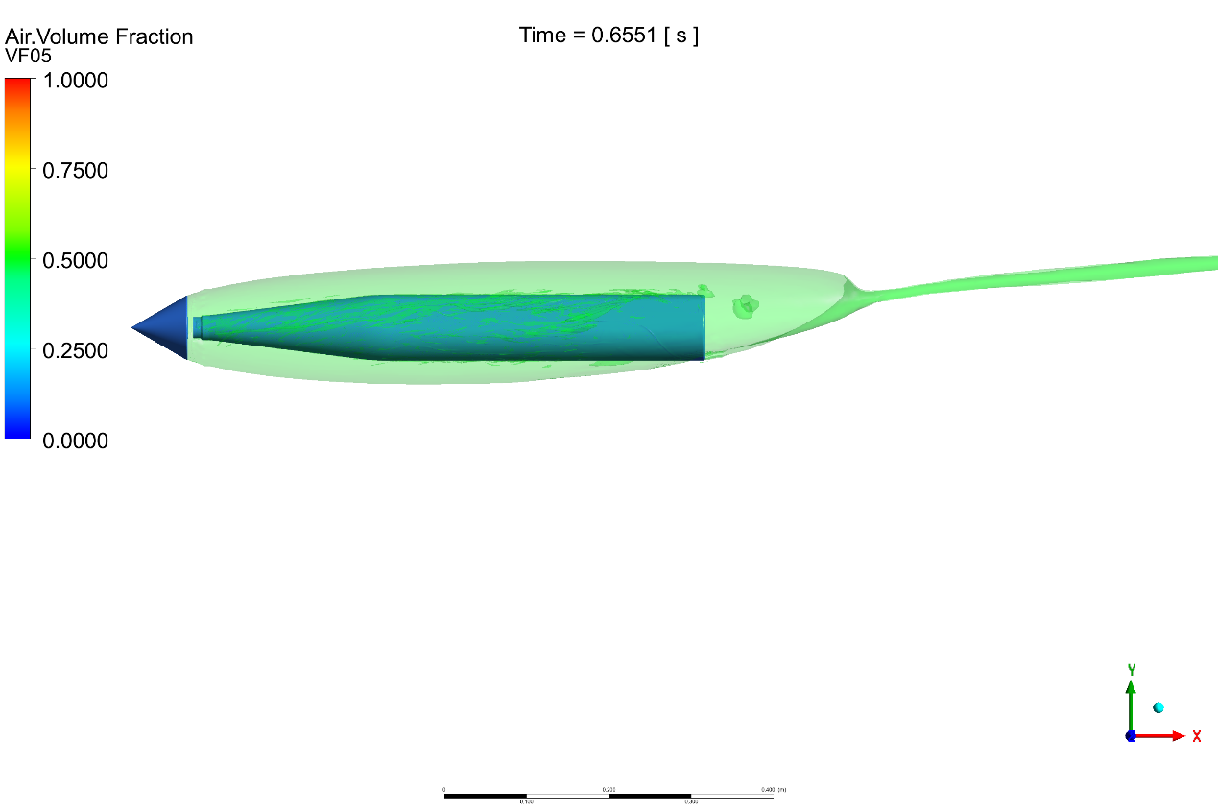

Figure 6 : Air VF iso surface 0.5

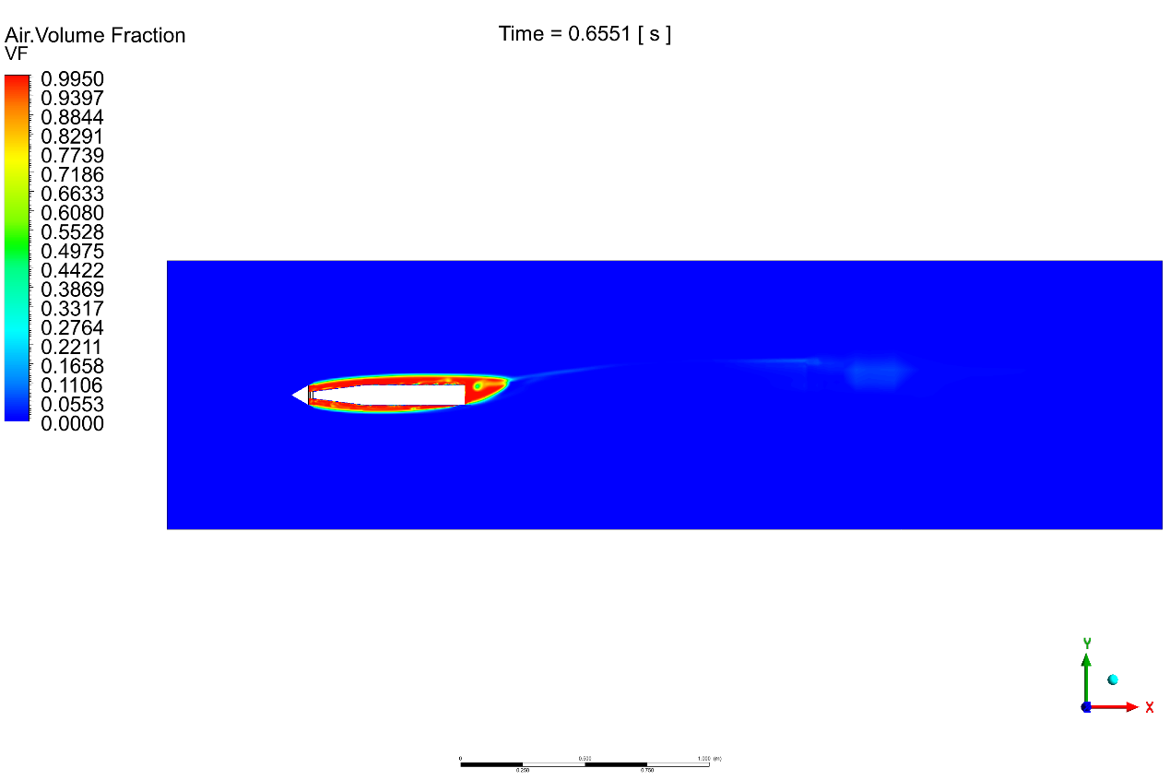

Figure 7 Air VF

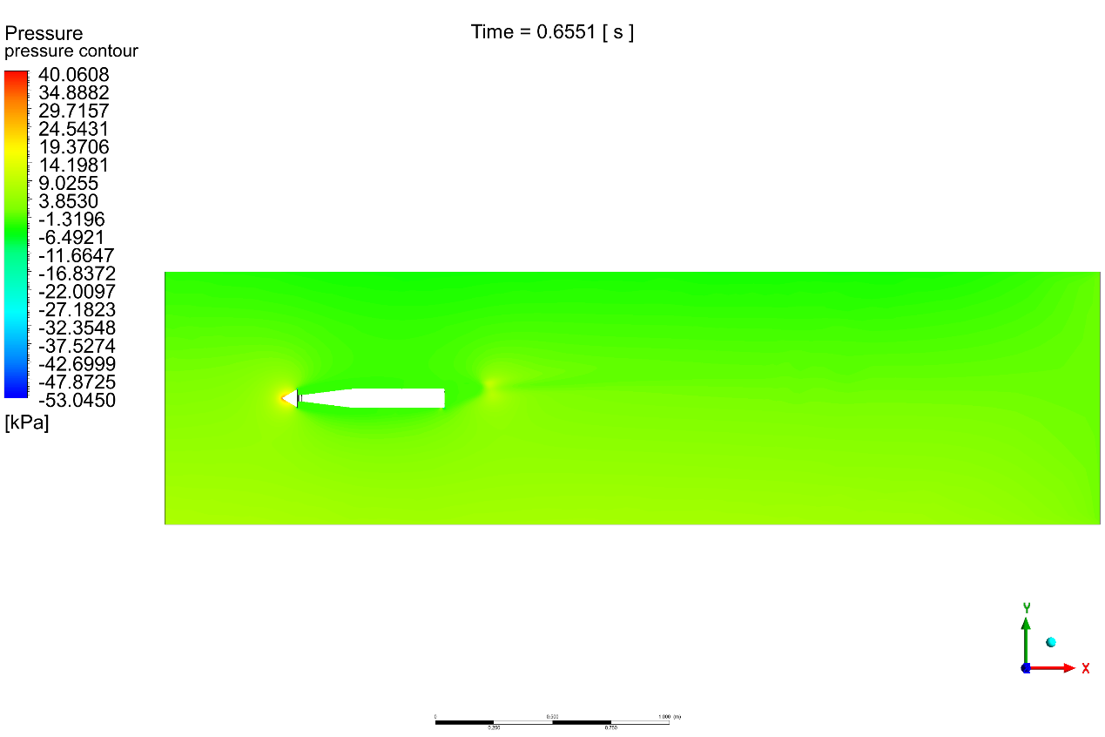

Figure 8 Pressure distribution

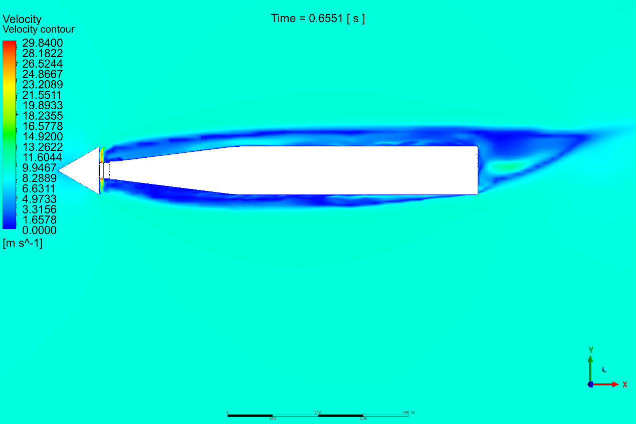

Figure 9 velocity distribution



Figure 10 drag with time

|  |  |  |
| --- | --- | --- |
| Comparison between Cavitator Design 40 deg and 60 deg | | |
| angle | 40deg | 60deg |
|  | 0.060405044 | 0.094147485 |
| Drag | At time | At time |
| Cavity width |  |  |

# References

al, A. e. (2012). Experimental investigation of supercavitating flows.

al, A. e. (n.d.). Experimental investigation of ventilated supercavitation behind cone-shaped with different angles and disk-shaped cavitators.

al, Y. e. (2022). Computational investigation on ventilated supercavitating flows and its.

[Kim, M.-J. (n.d.). Cavitator Design for Straight-Running Supercavitating.](https://www.mdpi.com/2076-3417/11/14/6247)